WeQuenGwayWin
Natural Healing Program Activities
Each person can choose which activity to join.
Natural Healing Program
Honoring Individuals
Healing & Sharing Circles
Sweat lodge
Ojibway Language
Shaking Tent Ceremony (Upon request)
Mida & Pipe Ceremonies
Spiritual & Emotional healing
Drumming
Singing
Fasting
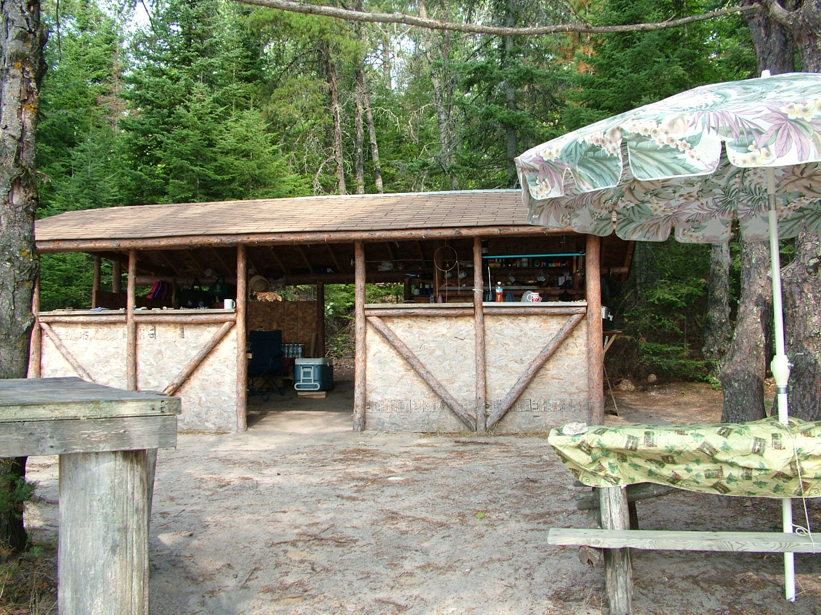

Meals
Everyone eats at one location and are encouraged to help in meal preparation and serving. This will promote community spirit and strengthen positive relationships. Participants are also responsible to help clean up after every meal. Special dietary needs must be stated during registration. Clan responsibilities become more apparent in duties and responsibilities.

WeQuenGwayWin
Other Services
WequenGwayWin provides a range of services which are made available on request. Individual training and service packages can be developed to suit your needs.
Individual & Group Counseling
Couples Workshops
Educational workshops on Alcohol, drugs, family dynamics, abuse and other issues.
Cross cultural Training
Aboriginal Teachings Clan System
Program Development
Proposal Writing
Stress Management Workshops
Youth Empowerment
Retreats 7 Grandfathers
Ojibway Language Camps
CISD Training
Abuse and Family Violence.
Ojibway Cultural teachings
Healing Retreats
Decolonization
Drum Teachings
Sweat Lodge
Mida Ceremonies
Fasting Preparation
Fasting
Educational materials are also available on services.
WeQuenGwayWin is a private firm that offers negotiable services and programs tailored to your needs.
The clan elders honor their sacred roles in the delivery of services based on traditional teachings.
Love, respect, sharing and caring.
WeQuenGwayWin
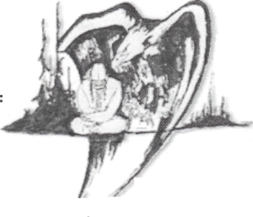

Natural Healing Program 2026
Residential School Healing.

An Alternative and innovative approach to healing that is effective.
Individualized Treatment Plans

Traditional Healing Methods

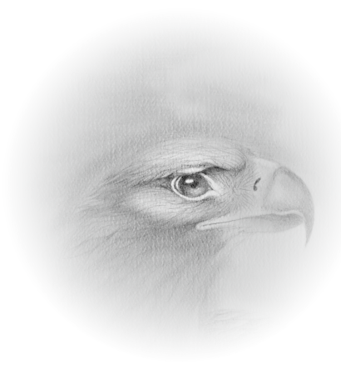
Start Dates for 2026

June 1-6 July 6-11
Aug. 3-8 Sept. 7-12

Ralph Johnson PaShawOneebinace
The Great Northern Pike Clan
(Program Director)
40 Sun & Sand Road Sioux Lookout ON P8T 0A7
(807) 737 – 0382
WeQuenGwayWin
Natural Healing Program 2026

Philosophy

We believe everyone can heal from within. The tools needed for healing have been with us since birth. Our fears, hurts, frustrations and grief can become our healers and learning to use them can move us further in our personal growth.

Experience your life to the fullest and learn to have your emotions work for you. The holistic approach to healing ensures psychological, spiritual, physical and emotional growth.

Learn natural healing techniques and eliminate the need for therapy or counseling and get on with the business of living. Applying these techniques in your daily life may contribute to personal progress and potentially benefit others.

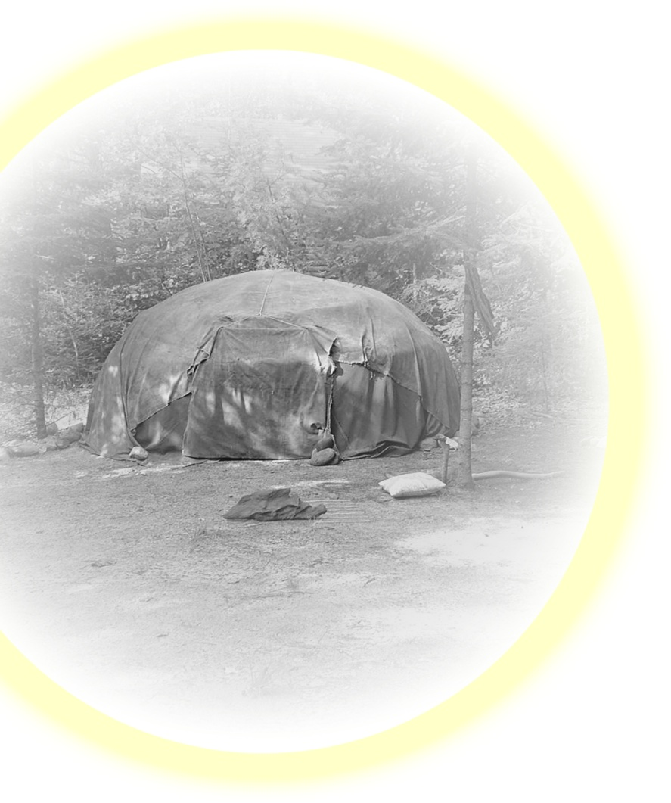
Grow from an atmosphere of love, fun, respect, understanding and caring in a natural setting. The healing process addresses addictions, emotional distress and childhood issues. A combination of clinically proven methods from Western psychology, psychotherapy and Traditional Ojibway teachings are combined to bring you this natural healing model.

Inquiries about healing or training in your area or community can be arranged if desired.

WeQuenGwayWin
Natural Healing Program 2026

Methodology

The process begins when the individual asks for help. The natural healing process has begun to take effect. Accepted participants receive three basic instructions for starting their natural healing. A book or an outline is provided as a guide. Daily lectures are conducted in a sacred teaching lodge. The sweat lodge, pipe, shaking tent, drum and mida lodge are utilized during the process. For group and family healing sharing circles are used to promote respect, compassion and caring. The insights that are learned will continue to heal in a natural way throughout your life. With love, respect and understanding as guides, the experience will continue to take you to greater heights of understanding and awareness.
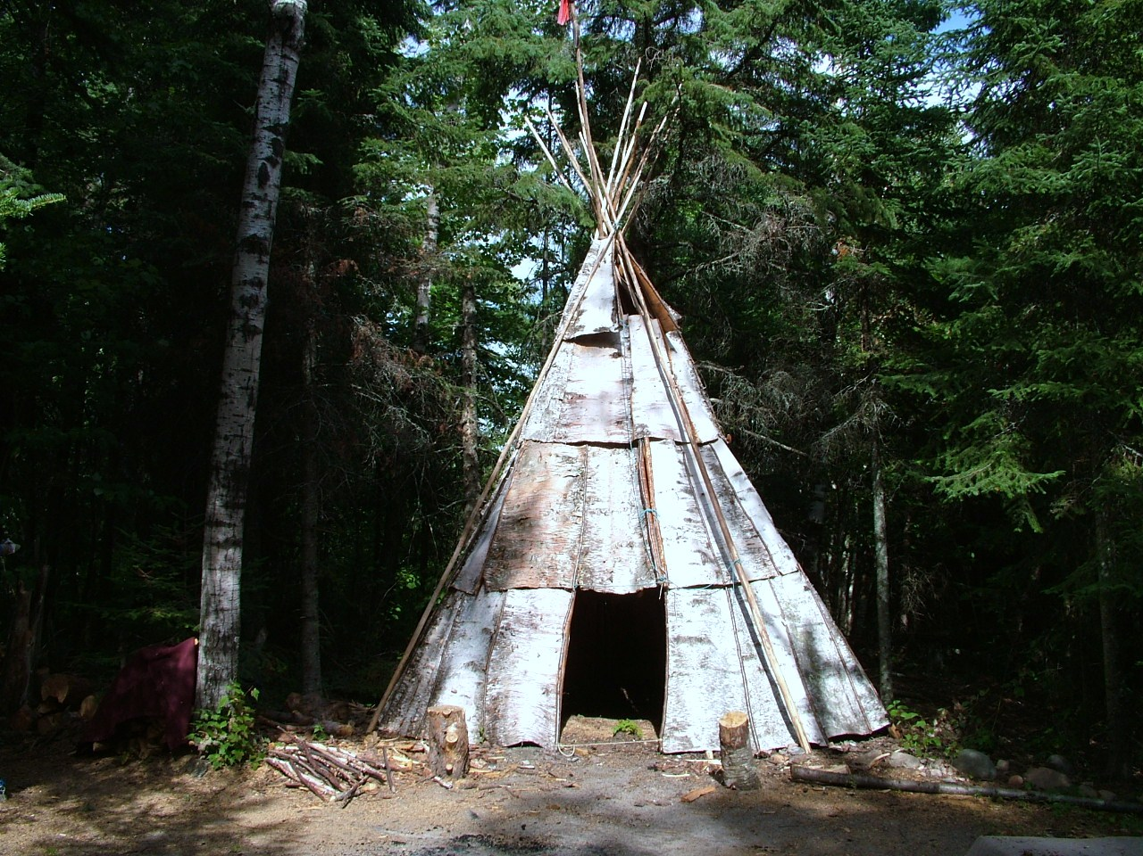

After Care
As part of the aftercare, individuals will be contacted in six weeks from completion of program. Another aftercare contact will be made after 6 months. All participants develop an aftercare plan and are encouraged to continue further healing.

WeQuenGwayWin
Natural Healing Program 2026

Requirements
People should dedicate a few days to personal growth and be open to change. A tobacco offering is sufficient to participate.

Bring clothing and personal hygiene items to last for the duration of program.

Setting
The healing program is conducted in a natural setting by the waters of Rainy Lake. This traditional healing site has been utilized since time immemorial.
Funding
WeQuenGwayWin is a private firm and is not funded by any agency or government program. Donations or a $1,000.00 registration fee is required to cover expenses for materials and other supportive measures. The IRS Health Support Services covers travel meals and accommodations for IRS survivors and other generations to the program. For IRS support contact: 1-888-301-6426 two weeks prior notice required for prior approval.

Confidentiality
We respect the individual’s right to privacy and confidentiality.

Responsibility
- Make your own travel arrangements.
- Be at location for pick-up on time.
Part of the travel is by boat, site not accessible by road.
Be alcohol and drug free.

