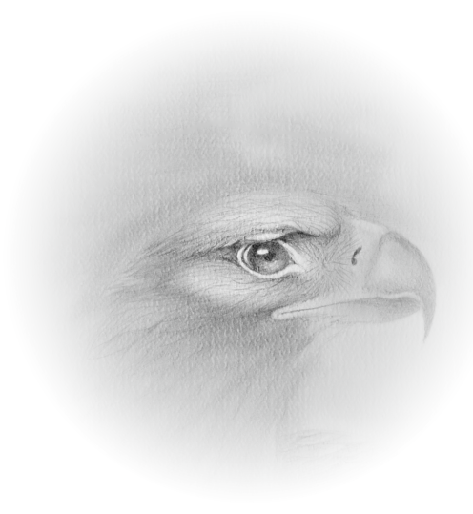
Registration Form
WeQuenGwayWin
Ojibway Immersion Program

Personal Information
Title Last Name First Name

Full Company/Organization Name (as registered)

Address

City Country

Telephone Fax

Mobile Email

Website of your company/organization

Ojibway Language Immersion Program
Participation Fees for 5 days $1,000.00
The fees cover the attendance of the program, lunches, breaks, suppers and all other program functions.

Method of Payment
Make cheque payable to: WeQuenGwayWin.

Cancellation Policy
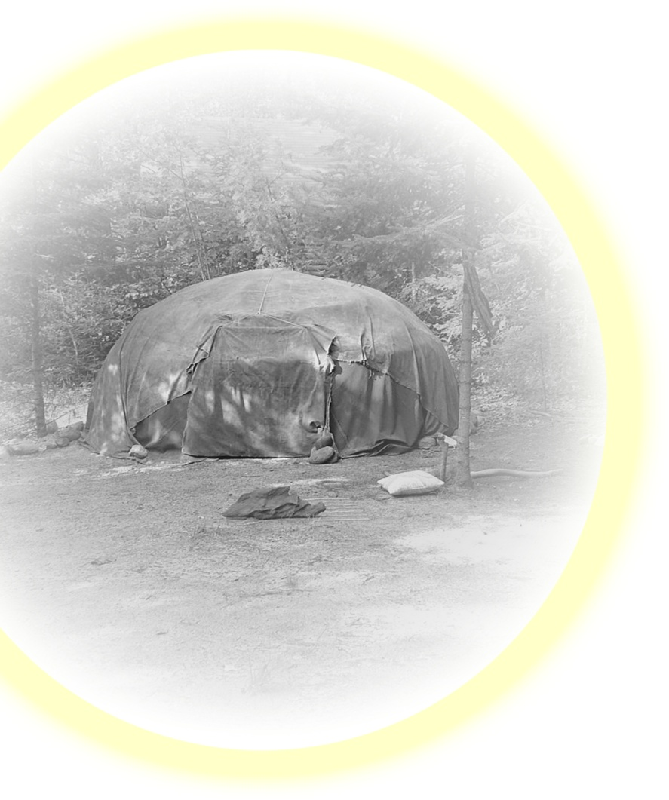
Any cancellation a week before start date will be subject to a 50% refund of participation fees. After that period, no refunds will be made for cancellations. Thank you for submitting your registration.
We look forward to welcoming you to our Ojibway Immersion Program.

Date: Signature:

Please return this form to WeQuenGwayWin.
E-Mail : pikeclan@hotmail.com
Certificate of completion for up to 60 hours of instruction in Ojibway language.

