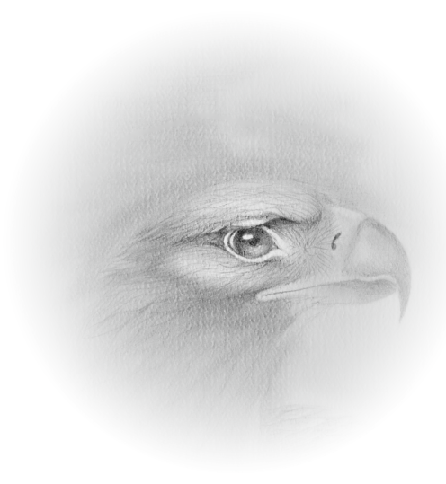
WeQuenGwayWin

CLAN System Teachings
Four Days of Youth Empowerment through the Seven Grand Father Teachings and
Leadership Skills
Training

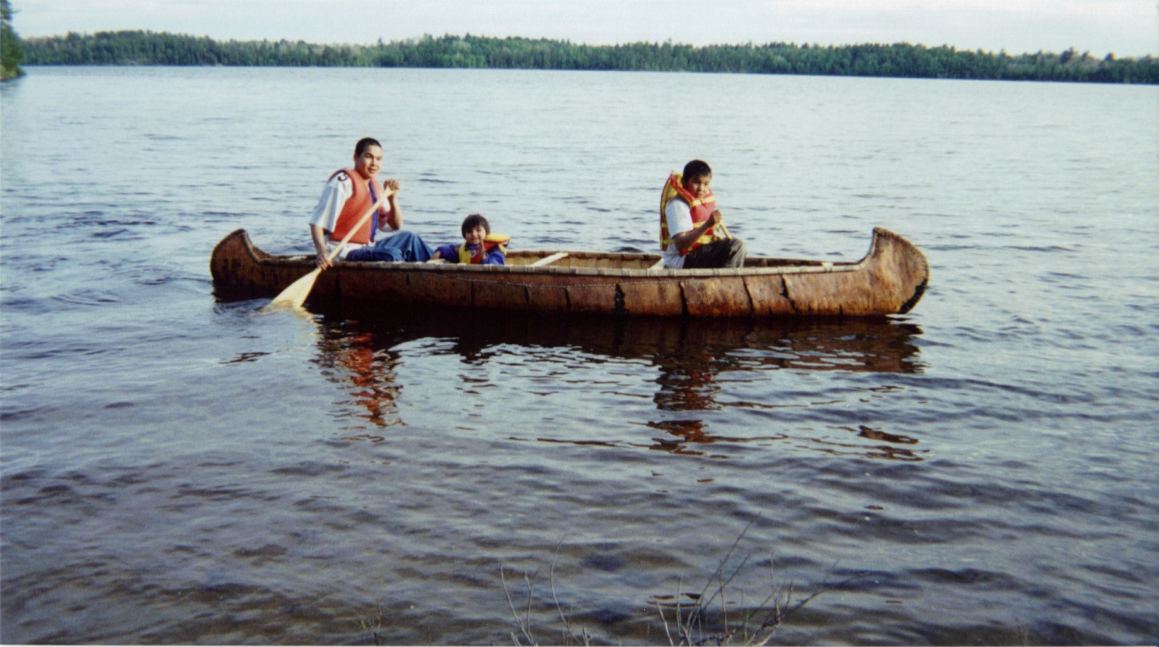

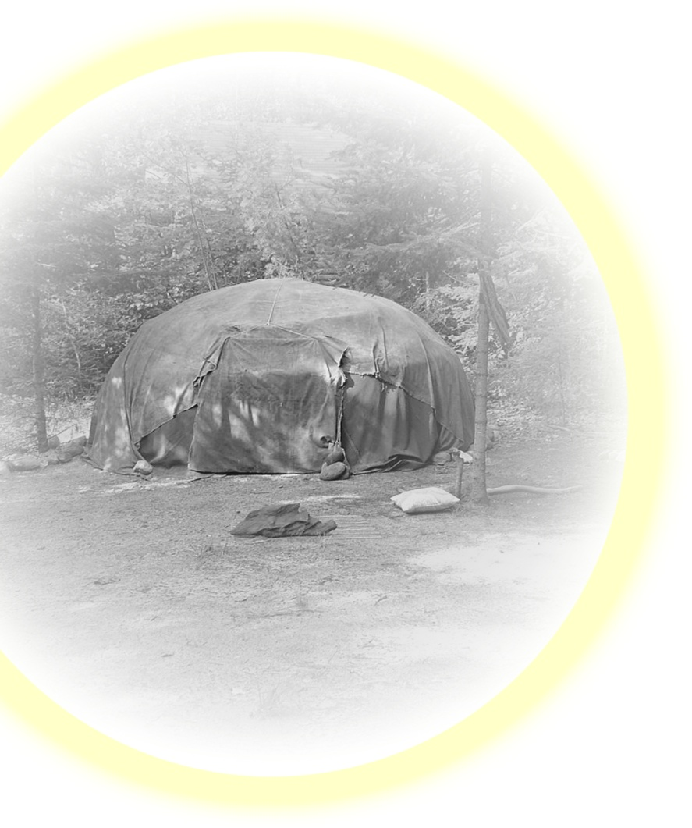
Participate in a powerful enriching and enlightening experience with Ojibway elders as they share their knowledge and use the Seven Grand Father Teachings and experiences as teaching tools on beautiful Rainy Lake Nigoonsemenecaning First Nation.

Register now by calling 1-807-737-0382 ask for Ralph Johnson (PaShawOneeBinace
Great Northern Pike Clan)
Registration fee is $1,000.00 per participant.

WeQuenGwayWin
Four Day Youth Empowerment Program.

The youth empowerment program is delivered by fluent Ojibway elders and are available 24 hrs a day on site. The location is a traditional site for growth and learning where traditional activities and teaching tools utilized are available. Participants are immersed in traditional customs and activities to honor the language and values of the Ojibway building self-esteem and an openness to learning. The schedule of activities are broken down into 4 separate categories:
- Games and activities. Leadership skills.
- Word Practice & Pronunciation of the Ojibway Language.
- Traditional Activities and 7 Grand Father Teachings
- Traditional Customs and practices.
- Story telling.
All materials used in Word Practice & Pronunciation are available for participants at cost. A list of resources available for purchase are listed on the last page. Each day will be opened with a Traditional drum and pipe. The youth are given an opportunity to learn and practice.

Day 1
10 am. Camp Set-up, Introductions Opening prayer, songs and Overview of program with Ice Breakers.
Break
10:15 - 11am. Tour of Camp and set-up.
11am - 12 pm. Ice breaker: Introductions and Expectations. Traditional Teachings (Teaching Lodge)
Lunch
1pm - 2:30 pm. Leadership Games. Warm-up exercise & RESPECT exercise,. Tasks and review.
Break
2:45 - 3:30 pm Traditional Activity. Elders teachings and guidance. Water sports.
3:30 - 4: pm. Free time till supper. Supper & Free Time (Games)
7pm – 9pm Story Telling Elders talk about values and beliefs. WISDOM exercise.
Ojibway Word Practice, Pronunciation and group games

Day 2
9 am - 10 am. Opening Warm-up exercise & Check in & review .
Break
10:15 - 11am. Traditional Teachings (Teaching Lodge) Ice breakers HUMILITY exercise.
11am - 12 p m Team Building exercises Warm-up exercise & Tasks assigned and review.
Lunch
1:pm - 2:30 pm. Leadership Games. Warm-up exercise & Tasks assigned and review.
Break
2:45 - 3:30 pm Traditional Activity. Elders teachings and guidance. BRAVERY exercise. Family members practice.
3:30 - 4: pm Free time till supper. Supper & Free Time
7pm – 9pm Story Telling Elders sharing circle, Sweat Lodge Ceremony optional.

Day 3
9 am - 10 am. Opening Warm-up exercise & Check in & review .
Break
10:15 - 11am. Traditional Teachings (Teaching Lodge) Ice breakers TRUTH exercise.
11am - 12 p m Team Building exercises Warm-up exercise & Tasks assigned and review.
Lunch
1:pm - 2:30 pm. Leadership Games. Warm-up exercise & Tasks assigned and review.
Break
2:45 - 3:30 pm Traditional Activity. Elders teachings and guidance. HONESTY exercise. Family members practice.
3:30 - 4: pm Free time till supper. Supper & Free Time
7pm – 9pm Story Telling Elders sharing circle, Sweat Lodge Ceremony optional

Day 4
9 am - 10 am. Opening with Drum and Pipe. Warm-up exercise & Check in & review.
Break
10:15 - 11am. Leadership Skills & Building self-esteem LOVE exercise. (Teaching Lodge)
11am - 12 noon Leadership Games
Lunch
1:pm - 2:30 pm. Word Practice & Pronunciation. Warm-up exercise Review of Verbs, names and explore other phrases.
Break
2:45 - 3:30 pm Traditional Activity. Prepare to leave. Evaluations and final circle.
Transportation to Ottertail or Crow Rock Landing for trip home.

Traditional activities include :
1. A nature walk identifying plants and medicines uses and how to prepare them.
2. Teaching and medicines of the water including a visit to sacred sites and rock paintings.
3. Birch Bark teachings and crafts.
4. Preparation of traditional foods and ceremonies.
5. Sweat Lodge Ceremony (optional)

Each participant will have an opportunity to participate and spend time with different elders each day.
Traditional meals will also be served throughout the week.

WeQuenGwayWin can also deliver this program in your community for dates that are more appropriate if desired, you can call us at the numbers listed at the first page.

Additional material and resources developed by WeQuenGwayWin pertaining to the Ojibway customs and traditions can be purchased if desired.

Meegwetch!

